### **findWormz Detailed Protocol**

1. **Prepare your slides:** Microwave a solution of 3% agarose in ddH20 until it boils. Remove from the microwave, mix the solution a bit until bubbles dissolve, return to microwave and bring to boiling a second time. Take a 1,000 μL pipette tip and remove the bottom third of the tip with scissors or a razor blade. This will allow you to pipette the viscous agarose gel solution. Set your pipette to ~500 μL, and dispense the melted agar onto a glass slide. Take a second glass slide with two layers of tape wrapped around each end, and gently press this taped slide over the slide with the hot agarose. Push on any large bubbles that appear in the agar to pop them and hold until the agar becomes cool. Remove the slide with the tape. If you are imaging many conditions, you can prepare multiple slides and keep them on ice until imaging.
2. **Put worms on the slide:** fill a 10 μL pipette with ~5 μL of sodium azide solution. Make sure to wear gloves while handling sodium azide. Apply a drop of sodium azide to the location on the agar pad you plan to place your worms. If you are adding multiple conditions to one slide, make sure you leave room to spread the worms out so they are not touching. This takes at least twice as much space as traditional imaging. Using a worm pick, grab worms from your plate without grabbing any bacteria. Place worms in the sodium azide droplet. Continue until you have achieved your desired sample size.
3. **Separate your worms:** The ideal time to separate your worms is after most, but not all of the sodium azide droplet has evaporated. You want enough liquid for worms to glide across the agar, but not too much that they do not stay in place when you remove your pick. If needed, apply a small amount (~1-2 μL) of additional sodium azide to reach this level of liquid. Using a traditional worm pick or an eyelash pick, gently pull the worms apart into groups of ~10-20 worms that are not touching but are still relatively close together (see example images, **Figure 5.10**). I find it easiest to align the long edge of a pick with the worm so you do not apply too much pressure to the head or tail and damage the worm. Some eggs and larva are OK if they get on the slide, they will be excluded from analysis. Do not add a coverslip to your slide—this will create a bubble around each worm making it impossible for the algorithm to trace. The absence of a coverslip will not affect your fluorescence quantification but does cause the worms to dry out faster. Make sure you image worms within ~20 minutes of separating them on the slide.

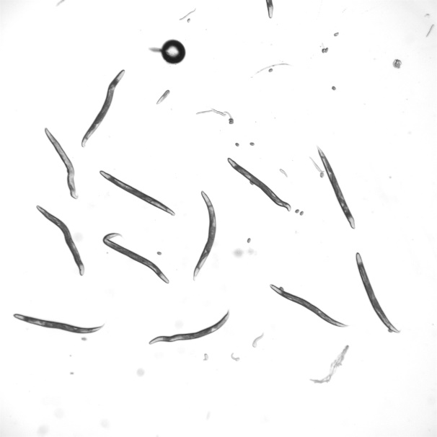

**Figure 5.10 Example brightfield input image for findWormz quantification.**

1. **Image your worms:** Once you have filled your slide, you are ready to image the worms. For the channel in which you take the brightfield image, set the scope parameters to enhance the contrast between the worm and the background. (i.e. darker worm and white background is better than gray worm and gray background). I typically set the aperture to ~70% and the intensity to ~40% (see example image above). Set the magnification to a level where you can see all the worms in your largest cluster. Changing magnification between conditions can affect your measurement of fluorescent intensity per pixel. Take images of all conditions. Note that worms touching the edge of the image will be excluded from your analysis.
2. **Naming your images:** The naming scheme is critical to correctly assigning experimental condition values to your final dataset. Each condition should receive a number, and each image taken of worms from that condition will receive a second number. A “key” to decode each condition will be given to the findWormz program to label your data. For example, if I am imaging two conditions (fed and DR), my “C1”, or condition1 would be the fed worms. C2 would be DR worms. If I take two images of fed worms, I would label them “C1_1” and “C1_2”. It is important that the letter C is before the condition number and an underscore separates the condition number from the image number. If you only take one image of a certain condition, you still need to include “_1” in the label.
3. **Exporting your images:** Once you have taken and named all of your images, export them all as TIF images. Do not overlay channels, export the brightfield and fluorescent images separately.
4. **Setup directories to run findWormz:** Create a main folder in which you will have three subfolders. The name of the subfolder can be anything you want. Add three folders within the main folder: “R code”, “input”, and “output”. Place the three R code files (analyzeWormz, findWormz, and worm_batch) within the R code folder. Place all fluorescent images you exported (TIFF files from brightfield and fluorescent channels) in the input folder. Create a csv file in which you label the information you want included with each condition. The first column of this csv file must be called condition_code, but you can add as many additional columns as you like with info about that condition. An example from one of my experiments is below. Name this file “conditions_map.csv” and put it in the inputs folder. Leave the output folder empty.

|  |  |  |  |  |
| --- | --- | --- | --- | --- |
| condition_code | RNAi | condition1 | condition2 | genotype |
| C1 | EV | fed | none | fmo2p::MC; MAH677 |
| C2 | EV | fed | OP50 | fmo2p::MC; MAH677 |
| C3 | EV | DR | none | fmo2p::MC; MAH677 |
| C4 | EV | DR | OP50 | fmo2p::MC; MAH677 |

**Table 5.2 Example input for the conditions_map file.**

1. **Run the code:** First, install R and Rstudio if you do not already have these programs on your computer. Links to download both are below:

* R: https://cloud.r-project.org/
* RStudio: https://rstudio.com/products/rstudio/download/

Then, open the worm_batch file in your R code folder. If it is your first time running the program, highlight lines 1-11 and click control+enter to install the packages you will need. These lines only need to be run once.

Then, edit line 14 of the code to specify your “working directory”, or the main folder that contains the three subfolders specified above. This filepath must be in quotations, and each level of folder must be separated by the character “/”.

This is the only line of code you will normally need to change. After doing so, select all the code in lines 14-37 (from “setwd” to the end of the program), and click “control + enter”. Worms_batch will populate your output folder with images of identified worms, a csv file with your quantification, and a csv file with the parameters used on this run. Both csv files will be timestamped with the date you ran the code.

Example output image: the first number is the assigned worm number. The number in parentheses is the “worminess score”. This score is included to help troubleshoot false negatives or false positives. If a non-worm object is identified, you can find the row from that file name and worm number in the analysis output spreadsheet and manually delete it.

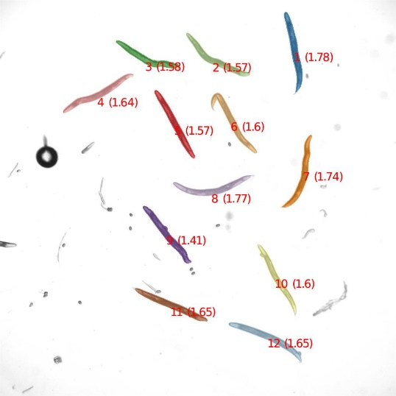

**Figure 5.11 Example output image from findWormz quantification.**

1. **Advanced options and troubleshooting:** Within the worm_batch code, you can change the inputs to line 13 (analyzeWormz) to troubleshoot or customize your output. These optional changes are explained below. If a parameter is not listed below, I highly recommend you do not change it.

* **troubleshootMode;** if you change this from “FALSE” to “TRUE”, the code will output four images with the changes made at each step of the code’s analysis pipeline. This is helpful if you want to decide which other parameters to change in order improve accuracy of worm identification.
* **Worminess_min_thr and worminess_max_thr:** these can be helpful to change if the code is mistakenly identifying non-worm objects. Look through your output files and find these objects. The second number in parentheses next to them is the worminess. Typically, non-worm objects will have a low worminess score below 1.35 or above 2.05. Changing the min and max worminess threshold will adjust what objects are excluded by changing that range. This can be helpful if you are imaging *C. elegans* strains with morphological phenotypes (ie *dpy*).
* **backgroundCorrect:** if you do not want the background fluorescence subtracted from your quantification, set backgroundCorrect to FALSE.
* **showPlots:** if you want to see the series of images the code produces as it is running in Rstudio, set showPlots to TRUE. Note that this will slow down the runtime some and will use a lot of memory.